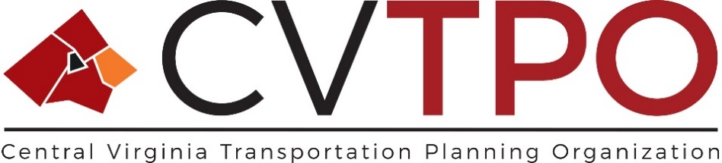

**Narrative of Changes to the 2024-2027 Transportation Improvement Program  
(Adopted by the CVTPO 1/18/2024)**

The following Amendments to the FY 24-27 Central Virginia Transportation Improvement Program (CVTIP) are proposed and reflect amendment request by the Virginia Passenger Rail Authority and Greater Lynchburg Transit Company (GLTC). These program funding changes, detailed below, have been reviewed and supported by agency staff.

The [Virginia Passenger Rail Authority](https://vapassengerrailauthority.org/) (VPRA) proposes the following project inclusion into the FY24-27 CVTIP to reflect inclusion of to reflect anticipated funding to the Commonwealth through FHWA Congestion Mitigation and Air Quality Improvement (CMAQ) funding to support Amtrak commuter services operating expenses for two trains on the Roanoke Route (Route 46) that traverse through the CVTPO region.   
  
FEMA considers the CMAQ-funded Amtrak projects to be exempt from air quality conformity requirements as the funding is going towards “operating assistance”, which is specifically listed as being exempt in Table 2 of EPA’s Transportation conformity rule.

The proposed Amendment, with adoption, will be located within Section 4: Public Transportation and Transportation Demand Management (TDM) Projects.

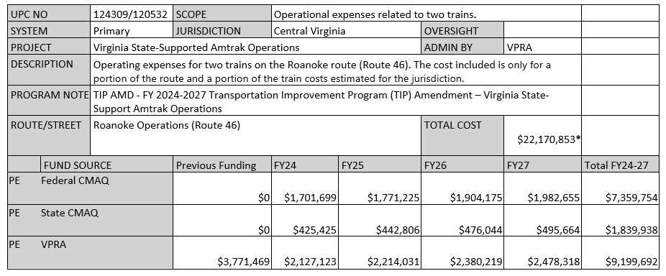

* Total cost includes operating expenses from previous founding and estimated expenses through FY27 as there are   
 operating expenses without an end date.

Funding presented in full dollar amounts.

The Virginia Department of Rail and Public Transit (DRPT), on behalf of the Greater Lynchburg Transit Company (GLTC) will execute the following Amendments to the CVTIP to account for anticipated new program funding, programmatic expenditure reallocation and project removal. The following outlines the full summary of GLTC funding program changes from the FY2024-2027 CVTIP adopted by the CVTPO May 18, 2023.





















