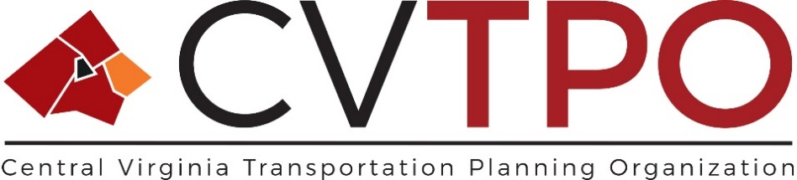
Narrative of Changes to the 2024-2027 Transportation Improvement Program
Administrative Adjustment February 22, 2024

The following administrative adjustments made to the FY24-27 Central Virginia Transportation Improvement Program (CVTIP) on 2/22/2024 reflect redistribution of Greater Lynchburg Transit Company (GLTC) Federal 5307 and local funding to allow for network storage and computer replacement. Adjustment reflects move to FY2024 and an amount change from $50,000 to $56,000. No state funding is associated with this project.

The Adjustments (denoted in $1,000s) are located within the following portion of the CVTIP:
- GLTC005 ADP Hardware project summary is located within the Section 4: Public Transportation & Transportation Demange Management (TDM) Projects and on page 21 of the CVTIP.
